Nanyang Polytechnic

Cable Harness E-Trainer for Hololens2

*Final Year Project - Documentation*

Brandon Ng

190501P

AAT1902

# Introduction

For my Final Year Project, I proposed to create an application to help facilitate the process of learning for students in terms of Cable Harnessing (refer to Module EGF312). This app would be used on a Mixed Reality headset called the Microsoft Hololens2. Utilizing the wonders of Mixed Reality, the app would display instructions and procedures to guide the students through the entire lab session without needing to refer to any worksheets. Should the students need help on any small procedures, like checking for wire continuity with multimeters or operating a contact extractor, there would be additional help provided by the app as well.

This concept was inspired by how big aerospace companies are embracing Augmented Reality (AR) in their operations as well. Lockheed Martin, for example, is [utilizing AR for their manufacturing and assembly processes](https://www.scopear.com/augmented-reality-in-aerospace-helping-speed-manufacturing-processes/). They have been working with software developers to animate processes shown in the “How-To” manuals. This has shown to drastically reduce the time taken to interpret assembly instructions by 95%. This proves that by harnessing the power of AR, we can make a lot of improvements to many of the things we know of today.

Before we get started on the nitty gritty, please be sure that you understand the basics of Unity. I will be explaining in-depth about what I have done, and it would be quite difficult to understand me if you did not know a thing about Unity. Do take the time to learn about this game development engine! Alright, let’s get started!

# [1] Basic Setup (from previous FYP student)

I started fresh on a new Unity project (version 2020.3.4f1) and had to first import 2 different packages into the project, namely the Vuforia Self-Development Kit (SDK) and the Mixed Reality Tool Kit (MTRK). This working instructions were discovered and practiced by a different FYP student, and it works so best to keep it the same.

Vuforia SDK Download [[com.ptc.vuforia.engine - Repos (azure.com)](https://dev.azure.com/vuforia-engine/unity-extension/_git/com.ptc.vuforia.engine/)]

1. Download the folder as ZIP

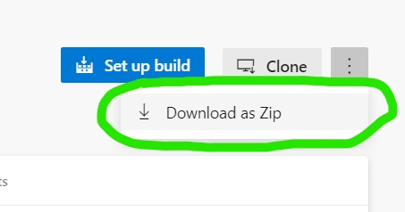

1. Extract the folder using a ZIP Extractor (download WinRAR if you don’t have a zip extractor), and look out for this file “Package”

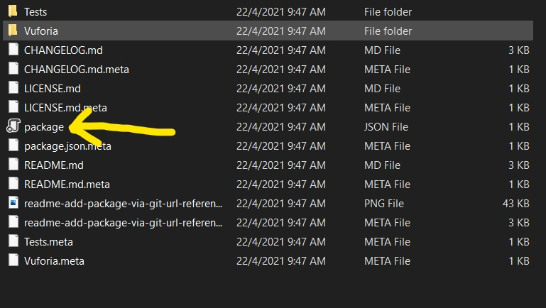

1. 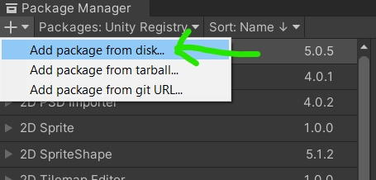Back in Unity, go to Add Package from disk, and add the file “Package”

MTRK Download [<https://www.microsoft.com/en-us/download/confirmation.aspx?id=102778>]

1. After downloading, open this file “MixedRealityFeatureTool”

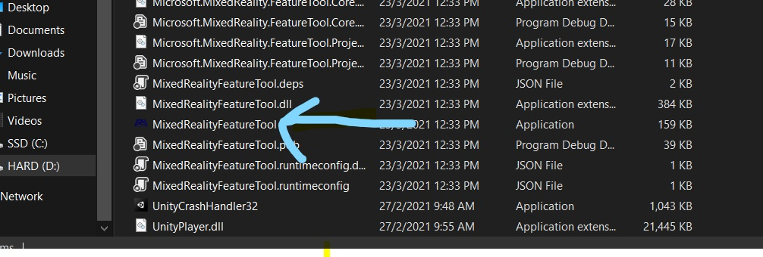

1. Go to the directory of the project, then discover features

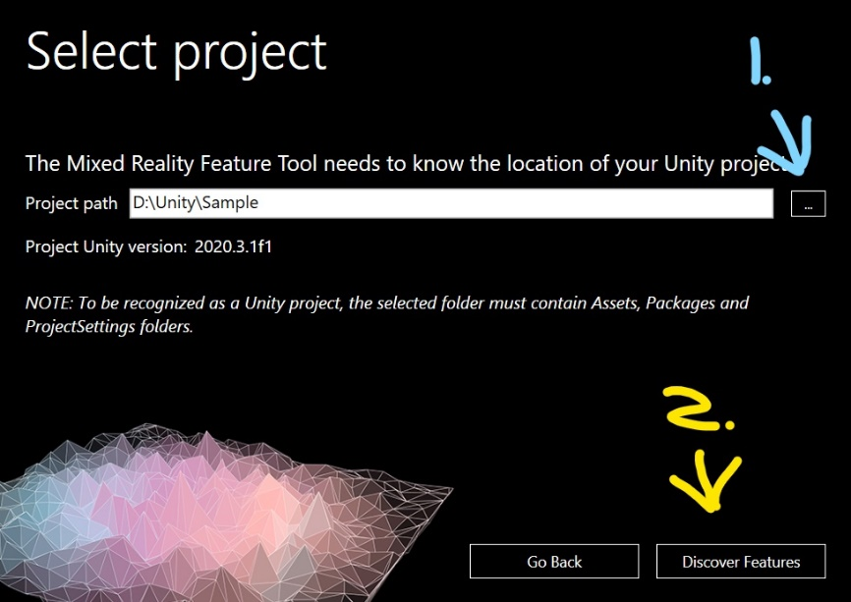

1. Select the following features, then get features. Later, just import and approve of the packages

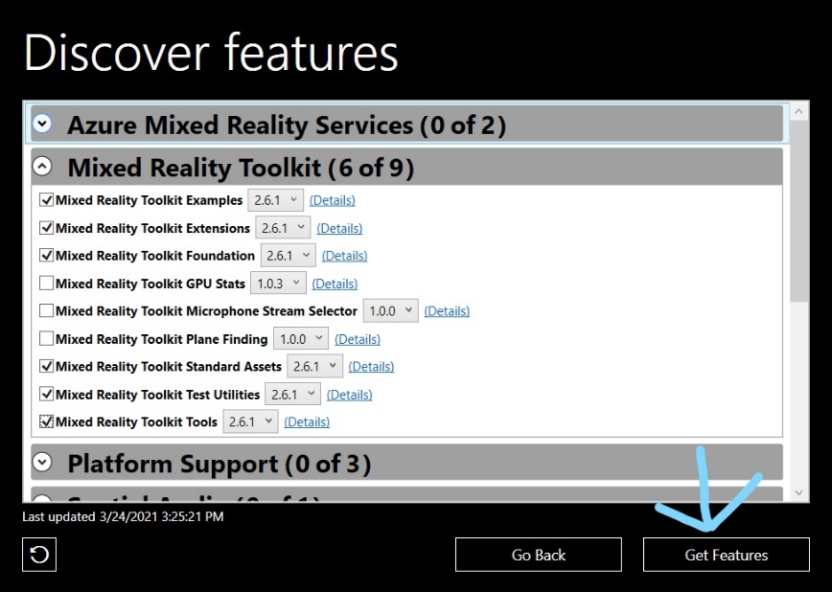

Now that I have successfully imported both kits into your unity project, I still must configure a few things first before starting to work on the project. Same as before, these configurations are “Standard Protocol” for MTRK development.

# [2] Important Configurations (from previous FYP student)

1. Add the MRTK to the scene and configure. This allows the scene to be played in the Hololens2

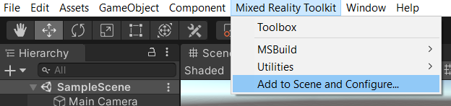

1. Go to project settings, and under XR Plug-in Management, check the “Windows Mixed Reality” box to prevent errors later. Do download XR Plug-in management in Package Manager if it is not in the project

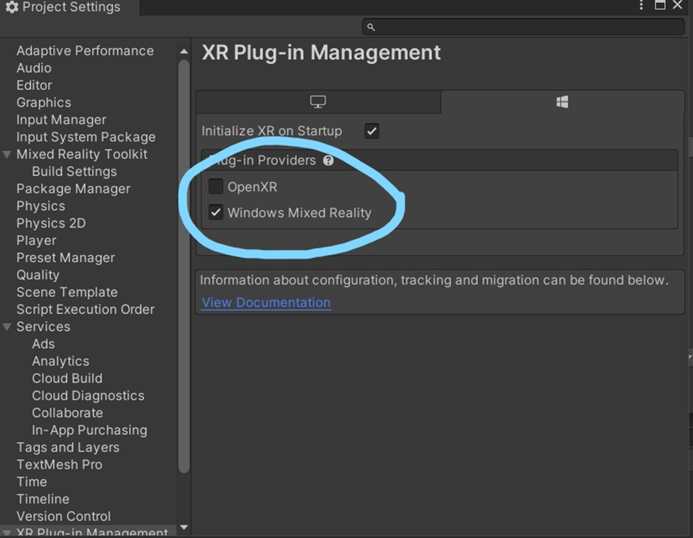

1. 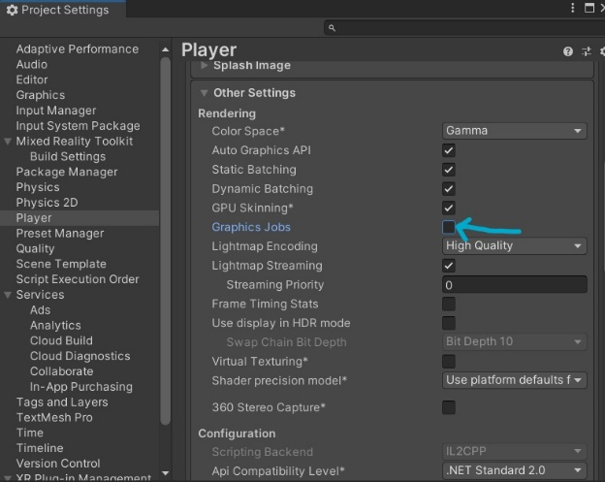Also, do disable “Graphic Jobs” in Other Settings
2. Under MixedRealityToolKit, select either DefaultXRSDK or DefaultHololens2XRSDK, and clone it

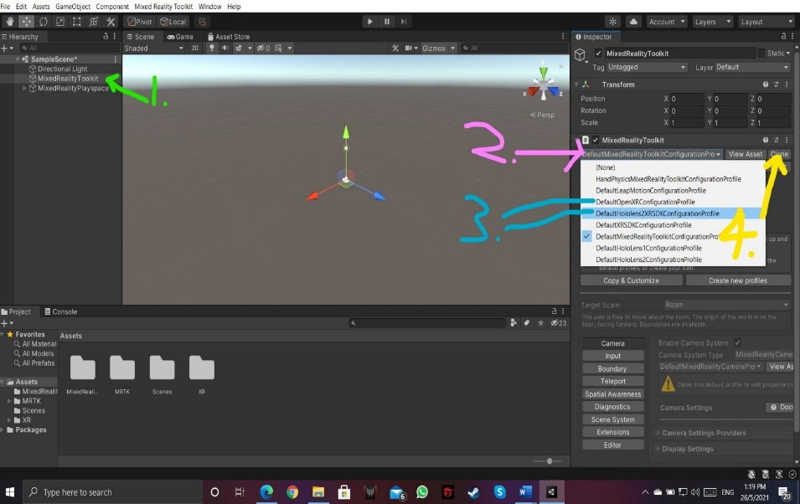

1. Select DefaultXRSDKCameraProfile from the Camera section, and clone it as well

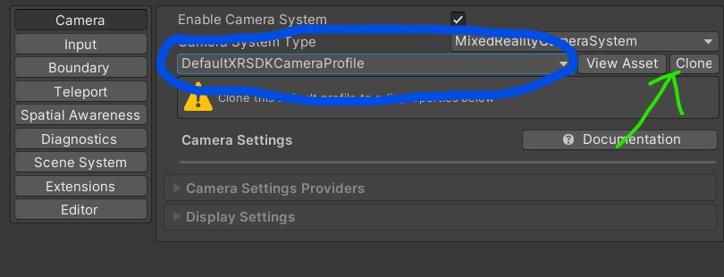

# [3] Adding Model Targets

After configuration, I can finally start on the project.

The main working principle for this app is to use the Hololens2 Camera to recognize the Cable Harness Circuit Board. Once the camera can recognize the distinctive features of the Circuit Board, the program would be able to do its’ magic. In my case, I programmed the app to cast a translucent overlay of the circuit board on top of the actual board.

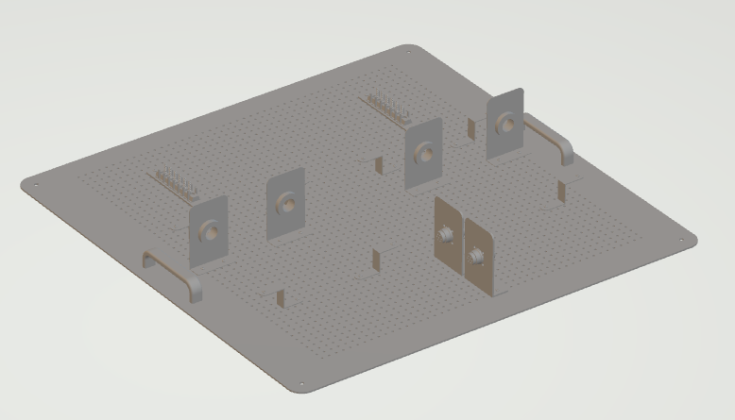First, I downloaded a software called [Model Target Generator](https://developer.vuforia.com/downloads/tool). It’s basically a desktop application that is converts a 3D Model into Vuforia Engine data to create Model Targets. This app supports .obj, . fbx, .pvz, .stl, .igs, .dae, .stp, and .vrml. Prior to downloading the app, I created an accurate 3D Model of the circuit board using NX software. The file was in .stl format.

Then, using the Model Target Generator, I got an asset file that I imported into Unity. After adding a Model Target Gameobject into the project (GameObject -> Vuforia engine -> Model Target), I modified the database to match the name of my Model Target.

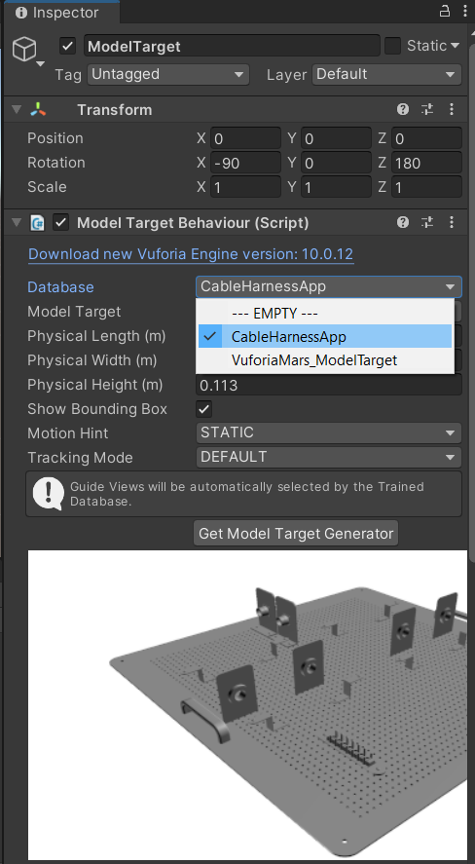

Now, the app is basically trained to recognize the circuit board.

# [4] App Creation

Now that I got things working, I began drafting up a basic structure on how the app is going to guide the user through the procedures.  
  
The idea is that the user will be greeted by a Start Menu when entering the app. After pressing start, the app will explain the features that the user will be seeing throughout the app so users would not be confused by the functions of each button.

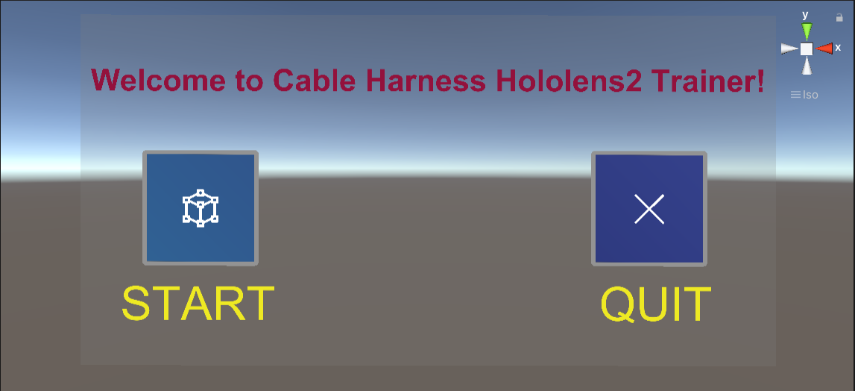

*Start Menu*

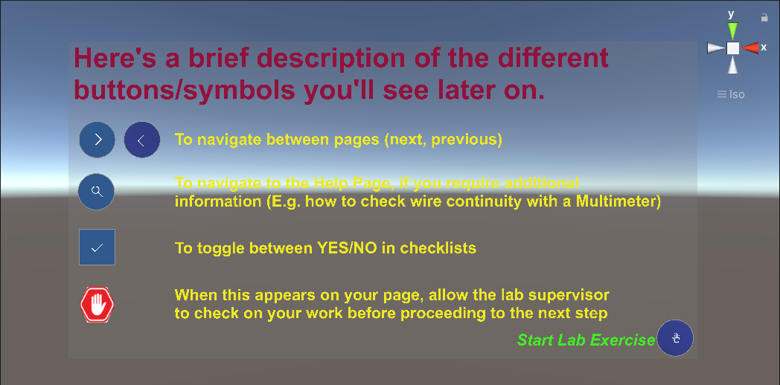

*Instructions*

Each step is essentially split into 3 parts; the procedure description scene, the help selection menu, and the help information. Let’s take {Step 1a} for example:

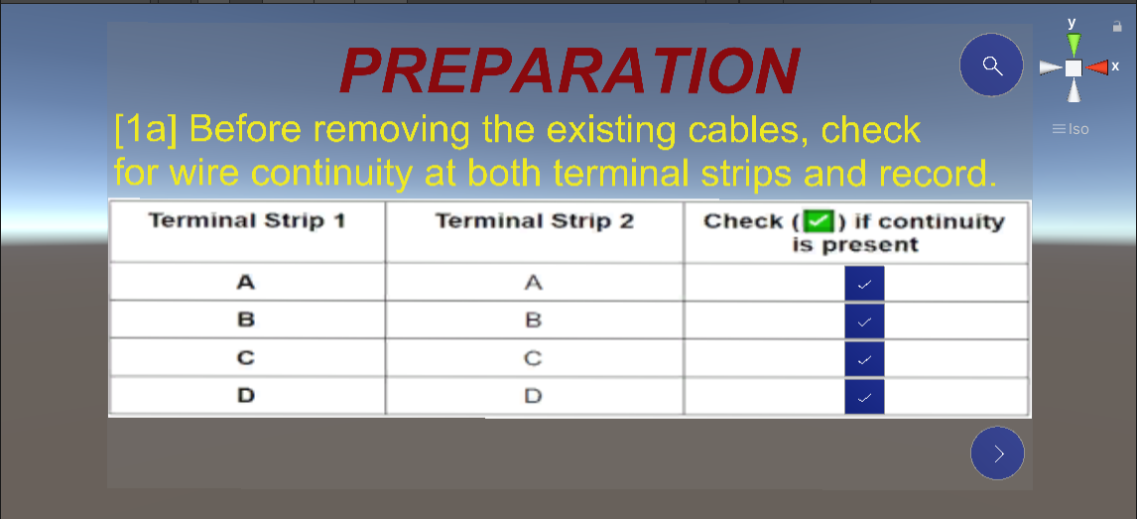

*Preparation – 1a*

This scene describes the details of the procedure for {Step 1a}. The “Next” button at the bottom right corner would bring the user to the next procedure, while the “Help” button at the top right corner would bring the user to the help selection menu should he require additional assistance.

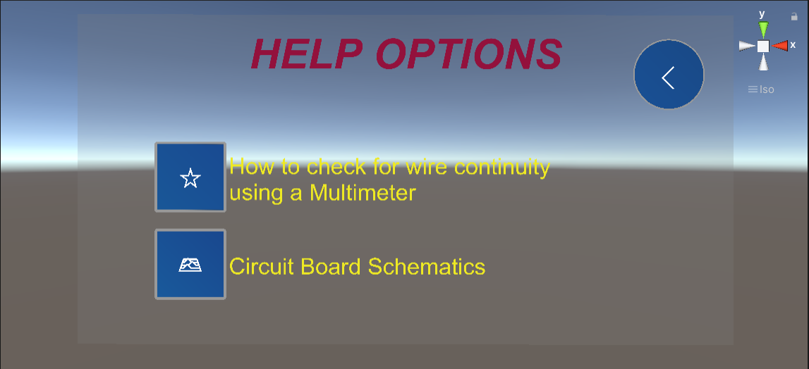

*Help – 1a*

Every Help Menu would contain information that users might need for that specific procedure. In the case of {Step 1a}, the user is required to conduct a wire continuity test using a multimeter. If the user needs help with that, they can click the first button to navigate to a different scene where helpful information regarding this topic is displayed.

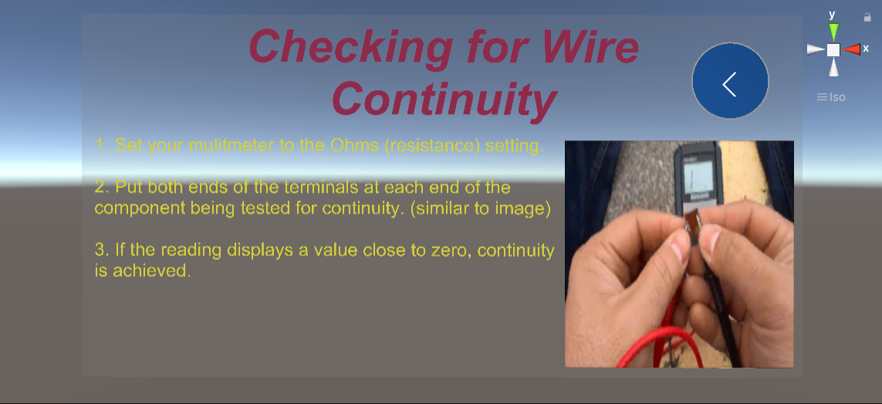

*How to check for Wire Continuity*

Another piece of information the user might need is the Schematics of the circuit board. I added that information for the user if they needed to refer to it as well.

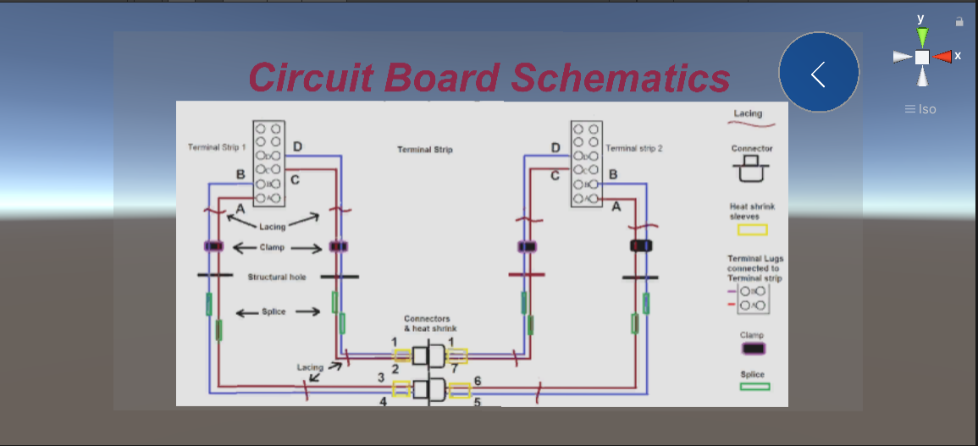

*Circuit Board Schematics*

Every help menu would include this information as it is quite important for users to have. Depending on the procedure, other information would be added in the help menu as well. This includes information on crimping of connector pins, terminal lugs and splices, tying of wax string and usage of contact extractors.

At the end of the procedures, after Final Inspection and Housekeeping, the user would finish the process by pressing the final submission button. This quits the app, as well as print out a PDF file onto Google Chrome. The PDF file contains the details of what the user has selected during the Wire Continuity checks in {Step 1a} and {Step 5a}.

Here is what a sample PDF would look like if the user has chosen to toggle the following checkboxes:  
{Step 1a}: Wire continuity present in A & B  
{Step 5a}: Wire continuity present in A, B, C & D

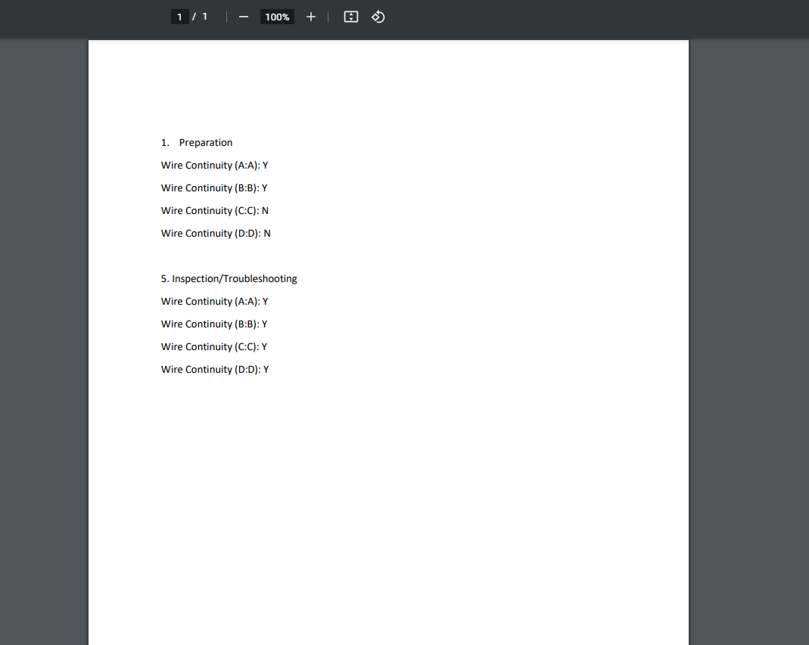

*Sample PDF file results*

Currently, it would not be able to save the user’s input for {Step 5b}. For now, the user would have to write down any findings during Troubleshooting manually on a piece of paper.

# [5] C# Scripts

## quitApp

This script contains one method, namely exitApp(). As the name suggests, when executed, it quits the app.

## PrepAA – PrepDD

These scripts are attached to the respective toggle boxes in {Step 1a} in Preparation. When a box is toggled by the user, onClick() will be executed, “remembering” the state that the box is in.

## InspAA - InspDD

The same as InspAA – InspDD but attached to the toggle boxes in {Step 5a} in Inspection.

## PrintingManager

This script has a chain of methods that get executed when pdfPrint() is executed. It extracts the information stored in “PrepAA – PrepDD” & “InspAA – InspDD” and translates it into TRUE/FALSE in relation to the user’s input. That information is then transcribed and formatted to create the PDF file to be displayed.

I referred to [this](https://www.youtube.com/watch?v=cMQdmEHwrDo) to learn how to print a basic PDF file in Unity. I don’t exactly know how the code is able to print a PDF file, but I do understand that part of the code is just formatting, all inside method GeneratingFile(). I then modified the code to allow me to print certain information that would vary, based on what the user has input.

# [6] Future Development

There will always be room for improvement, and it’s the same for this prototype. I have had 4 weeks less to work on this project, but I still managed to make things work. I did have a few big ideas that seemed possible (or not), but there was no time left to explore and experiment.

1. **Ability to recognize other trainer models**

For the EGF312 module, there exists many other circuit boards that have other kinds of lab procedures to be done as well. If this app gets accepted as a new form of learning for students, there would be many opportunities to program another app like this one to suit another kind of circuit board.  
  
However, the time taken to create a CAD model of the circuit board may vary. In my experience, I had created the model of the circuit board using NX software in a day. This was possible only because I had some help from friends, not to mention that the circuit board was not even that complex in the first place. If you need to model a circuit board with a much higher complexity, using a different method may be advised (look up Vuforia Object Scanner).

IF the CAD model that we have is capable of being recognized even though the camera is scanning a different circuit board, it will make programming another similar app much easier. This would only be possible if the distinctive features on the CAD model is prominent on the other circuit board. Even though the CAD model is obviously not the same as the actual circuit board, the Vuforia Engine only considers the prominent features to “recognize” the circuit board. You can say that there’s a margin of error present here, but the extent of this margin is impossible to quantify. Thus, if you can create a “generic” CAD model that contains prominent features present in every circuit board that exists, you would be able to program future apps with ease.

1. **Inspection Point Improvements**

In the worksheets currently, students are supposed to sign off at every step. This should be implemented in the app as well. I’m not sure if there’s a feature where you can do keyboard strokes on the Hololens2, but this could be something to investigate.

1. **PDF Improvements**

The basic PDF file is just the beginning. The favored PDF file would be to contain the entire softcopy of the worksheet, filled out as the user navigates through the procedures. I’m not sure if this is possible, as the code I have seen only allows me to print characters and format them. To be able to insert images, as well as lines and borders would be a different code altogether. Maybe there is a different approach to this?

# [7] Porting the app into Hololens2 Device (from previous FYP student)

After creating the app, you will need to build the app in Universal Windows Platform and then do a number of steps before the app is installed into the Hololens2. As usual, this is just “Standard Protocol”.

1. Make sure both your PC and Hololens 2 has developer mode on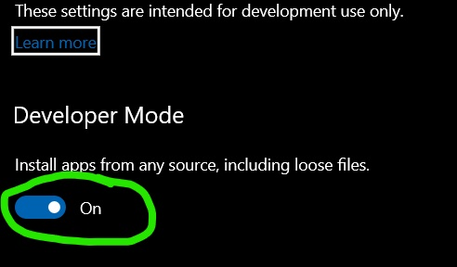

This can be found in the settings for both devices.

1. Under build settings, switch the platform to UWP.

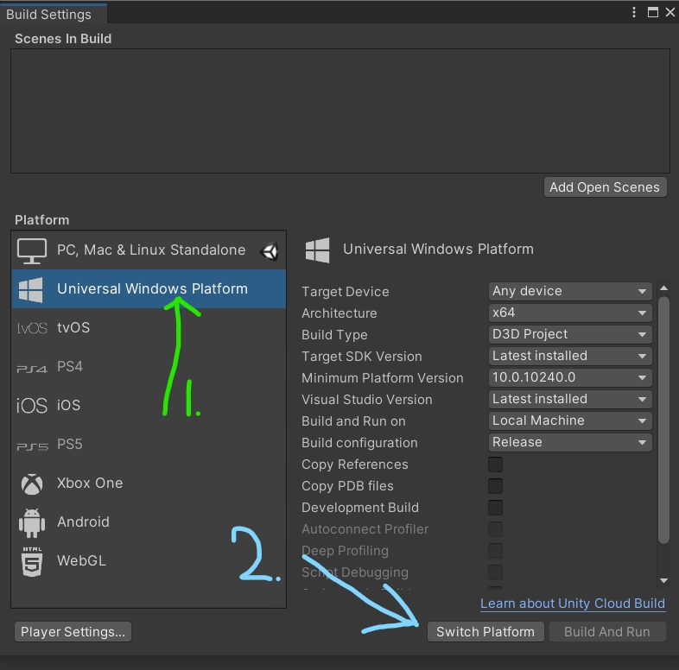

1. Make sure that target device is set to any device or Hololens2. I would recommend using Hololens2 since the model will look clearer. Remember to follow exactly what the other settings are in order to build the app correctly (i.e. build type must be D3D, Build and Run on Local Machine, etc.). Once that is done, press build.

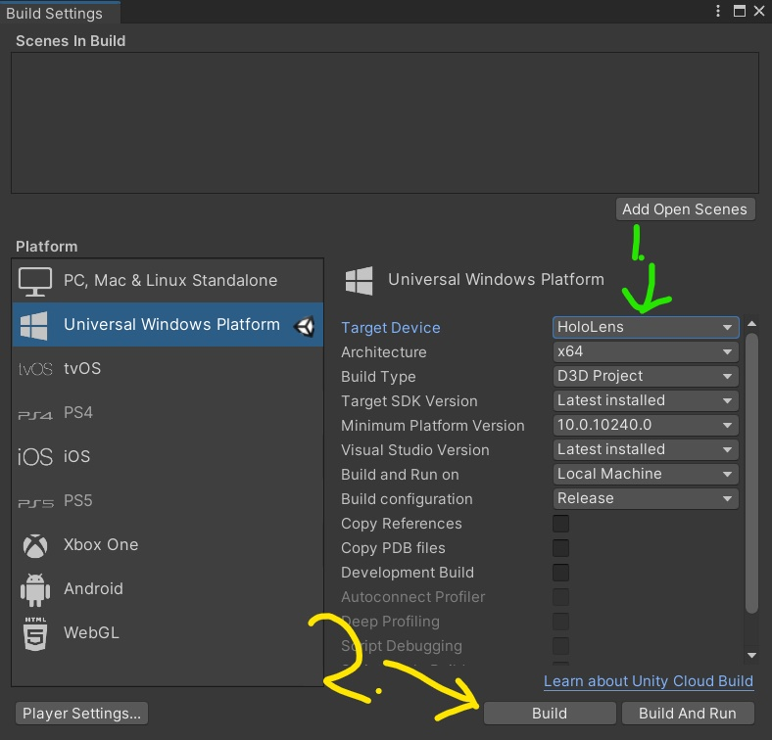

1. Then go to your files and open the Visual studio file. It should have the name of “blahblahblah”.**sln**

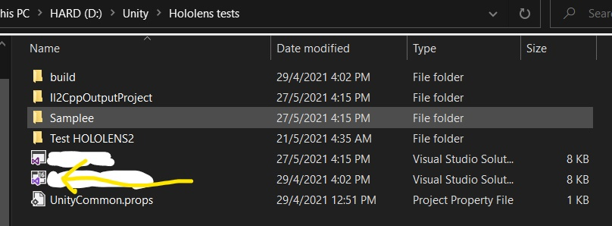

1. When Visual studio is opened, select remote device and open the debug properties.

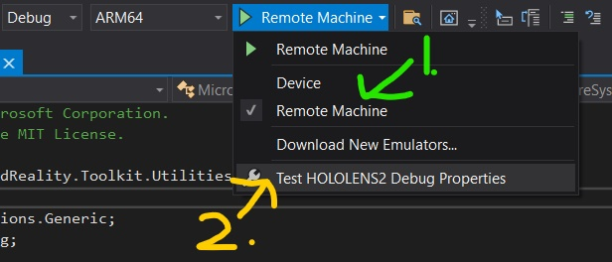

1. Make sure you PC and Hololens 2 are connect to the same Wifi and enter the IP address into the machine name.

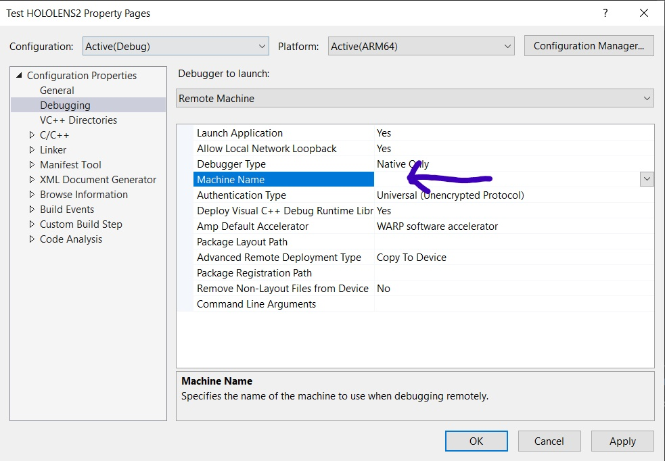

1. Choose the debug config and ARM64 platform.

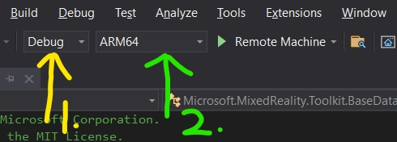

1. Finally press Remote Machine and wait till the game starts in the Hololens 2.( it will take quite some time.)

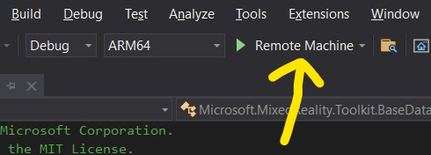

# [8] Final Thoughts

I am writing this now as I sit on my lab chair on the last day of my FYP. I just completed my presentation, and it could have gone way better.

Trust me when I say this, coding is not all that bad. If you are here because you love programming, good for you! If you aren’t here because of your interests, then you are going to have a tough time. Let’s just say that you must have 100% of your mind into the game if you really want to perform well in this FYP. But it really gets difficult sometimes.

Sometimes, you might want to pull out all your hair because certain features aren’t possible. You might slam the table because even though you copied some code in the Internet word for word, it just doesn’t work in your script. Try to have that perseverance to push through though! If it doesn’t work, try a different approach. Once you get a difficult problem to be solved, you’ll be extremely satisfied.

After finishing my project, in hindsight, I could have completed way much more if I were more hustled and ambitious. 12 weeks may seem like a long time, but as the weeks crawl by, you’ll slowly feel more cornered and anxious, so please keep track of time. And I don’t mean that by creating a fake Gantt Chart or something. What I did: After solidifying my job scope, I could roughly tell how much work I would need to do to get the completed result. Then, I strategized my time wisely so I would know how much work I had to do, as well as how much time I had to do it as well. This way, you won’t be super stressed out, and you know that in the long run, you would “make it in time”.

Another piece of advice: during your presentation(s), please label all your technical terms and phrases correctly. Once, I was stupid enough to call my app “a software” for some reason, and that did not go very well. Give credit to your supervisor by adding their name(s) onto your slides; don’t conclude with your learning experience because they don’t seem to care very much about it, talk about whether you have completed your Project Scope or not, any if there are any issues that require solutions, things like that. Presentation is very crucial, and if you screw up any basic things like mislabeling your headers or using an incorrect technical term, you will “kena whack” by the assessors. But don’t let that get to you!

Alright, I have given you whatever piece of advice I have. All the best!